LOMA LINDA UNIVERSITY
School of Behavioral Health
Behavioral Health Summer Academy

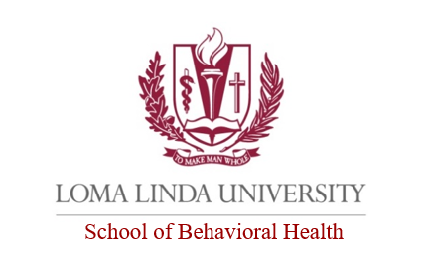
Application (Deadline June 30, 2020)
The completed application form is to be signed by the applicant, saved as a PDF document and emailed to bbuckles@llu.edu.

Applicant Information
Full Name: |  |  |  | Date:
 | Last | First | M.I.

Address:
 | Street Address | Apartment/Unit #

 | City | State | ZIP Code

Phone: |  | Email:

Social Security No.:

Are you a citizen of the United States? | YES | NO | Are you 18 years of age or older? | YES | NO

Education
Academy/High School Attended:
From: |  | To: |  |  | Did you graduate? | YES | NO

Have you applied and/or been accepted to a College or University? |  | YES | NO
What is the name of the College or University you plan to attend?
What is your intended area of study?
Date you plan to enroll:

Reference
Name of the person sending a recommendation for you: (One letter required from your principal or your school counselor.).
Full Name: |  | Principal:
 | Or
Full Name: |  | School Counselor:
Recommendation Letter: Completed applications must include one letter of recommendation and support from their academy or high school principal or school counselor. Letters of recommendation must be on academy/high school letterhead, signed, saved as a PDF document and emailed to bbuckles@llu.edu directly from the recommender's email account.

Personal Statement
The Personal Statement is a 250-word statement that describes your future college and career plans, how this program would help you in the pursuit of your plans, and your commitment to serve others.

Disclaimer and Signature
I certify that my answers are true and complete to the best of my knowledge.
I understand that false or misleading information in my application will result in the denial of my acceptance to the Behavioral Health Summer Academy
Signature: |  | Date:

